**Topics: Descriptive Statistics and Probability**

1. Look at the data given below. Plot the data, find the outliers and find out $μ, σ, σ^{2}$

|  |  |
| --- | --- |
| **Name of company** | **Measure X** |
| Allied Signal | 24.23% |
| Bankers Trust | 25.53% |
| General Mills | 25.41% |
| ITT Industries | 24.14% |
| J.P.Morgan & Co. | 29.62% |
| Lehman Brothers | 28.25% |
| Marriott | 25.81% |
| MCI | 24.39% |
| Merrill Lynch | 40.26% |
| Microsoft | 32.95% |
| Morgan Stanley | 91.36% |
| Sun Microsystems | 25.99% |
| Travelers | 39.42% |
| US Airways | 26.71% |
| Warner-Lambert | 35.00% |

Solution –

Mean = 33.2713

Standard Deviation = 16.9454

Variance = 287.1466

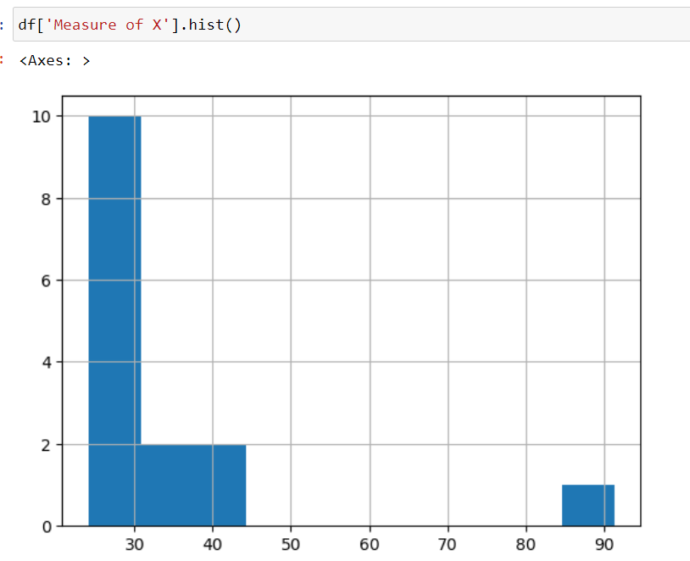

Outliers = 91.36 which corresponds to Morgan Stanley company



Answer the following three questions based on the box-plot above.

1. What is inter-quartile range of this dataset? (please approximate the numbers) In one line, explain what this value implies.

IQR = 12 – 5 = 7. Represents 50% of the data between 25% and 75%

1. What can we say about the skewness of this dataset?

More data concentrated to the left. Positive skew

1. If it was found that the data point with the value 25 is actually 2.5, how would the new box-plot be affected?

The mean value would change and the skewness will increase



Answer the following three questions based on the histogram above.

1. Where would the mode of this dataset lie?

Two modes are there at 5 and 7 approx.

1. Comment on the skewness of the dataset.

Positive skewness. More data concentration on the left.

1. Suppose that the above histogram and the box-plot in question 2 are plotted for the same dataset. Explain how these graphs complement each other in providing information about any dataset.

Both are positive skewed plots. There is an outlier at point 25.

1. AT&T was running commercials in 1990 aimed at luring back customers who had switched to one of the other long-distance phone service providers. One such commercial shows a businessman trying to reach Phoenix and mistakenly getting Fiji, where a half-naked native on a beach responds incomprehensibly in Polynesian. When asked about this advertisement, AT&T admitted that the portrayed incident did not actually take place but added that this was an enactment of something that “could happen.” Suppose that one in 200 long-distance telephone calls is misdirected. What is the probability that at least one in five attempted telephone calls reaches the wrong number? (Assume independence of attempts.)

P of one call being wrong in 200 = 1/200 = 0.005

P of one call being right in 200 = 1 – 0.005 = 0.995

P of at least one call being wrong in 5 attempts = 1 – P of all 5 calls being right

* P = 1 – (0.995)^5 = **0.0247**

1. Returns on a certain business venture, to the nearest $1,000, are known to follow the following probability distribution

|  |  |
| --- | --- |
| x | P(x) |
| -2,000 | 0.1 |
| -1,000 | 0.1 |
| 0 | 0.2 |
| 1000 | 0.2 |
| 2000 | 0.3 |
| 3000 | 0.1 |

1. What is the most likely monetary outcome of the business venture?

$2000 is the most likely outcome as it has the highest probability

1. Is the venture likely to be successful? Explain

-2000*0.1 + -1000*0.1 + 0*0.2 + 1000*0.2 + 2000*0.3 + 3000*0.1 = 800

The positive outcomes outweigh the negative outcomes. So there is a chance for the business to be successful.

1. What is the long-term average earning of business ventures of this kind? Explain

-2000*0.1 + -1000*0.1 + 0*0.2 + 1000*0.2 + 2000*0.3 + 3000*0.1 = 800

1. What is the good measure of the risk involved in a venture of this kind? Compute this measure

Standard Deviation = 1870.828